# 

Questionnaire Management System

October 8, 2024 – November 23, 2024

Table of Contents

Project Overview 3

Project Description 3

Progress Overview 4

Initiation & Planning (October 8 – October 15, 2024) 4

User Interface Development (October 16 – October 31, 2024) 4

Questionnaire Management Functionality (November 1 – November 10, 2024) 4

System Design (October 16 – November 5, 2024) 4

Testing and Validation (November 11 – November 20, 2024) 4

System Features Overview 5

Registration Page 5

Login Page 6

Reset Password Page 7

Dashboard Page 8

Profile Page 9

Create Questionnaire page 10

View Questionnaires Page 11

Create Questionnaire Modules Page 12

View Questionnaire Modules Page 13

Questionnaire View and Response Page 14

User Management – View Users page 15

User Management – Roles & Permissions Page 16

Technologies Used 17

Required Data 17

Data Usage 18

Future Work 18

Backend and Infrastructure Enhancements 18

Advanced Features 18

Security and Access Control 18

Testing and Quality Assurance 18

Documentation and Deployment 18

# Project Overview

*This documentation provides a comprehensive view of the* ***NMU Questionnaire Management System (QMS)****, outlining the purpose, core components, and accomplished work during the period from* ***October 8, 2024*** *to* ***November 23, 2024****. The* ***QMS*** *is designed to streamline the creation, management, and analysis of questionnaires, offering a user-friendly platform to gather and analyze feedback efficiently. This system incorporates various modules, including* ***questionnaire creation****,* ***user management****,* ***response handling****,* ***analytics****, and* ***reporting****.*

# Project Description

**Questionnaire Management System (QMS)** is a web-based application specifically designed **for New Mansoura University** to facilitate the creation, management, and analysis of questionnaires. This system is **tailored for the university's administrative and research needs**, offering a streamlined solution for **gathering student feedback**, **conducting campus-wide surveys**, and **performing in-depth data analysis**.

The QMS provides an intuitive interface that allows administrators and educators to design customized questionnaires, distribute them to students and faculty, and monitor responses in real time. Built with scalability and security in mind, the system incorporates essential features such as user authentication, response management, data validation, error handling, and analytics, ensuring that data is both accessible and secure. Key features of the system include:

* **Questionnaire Builder:** A dynamic, drag-and-drop tool for creating questionnaires with various question types, including multiple-choice, short answers, rating scales, and more. This feature supports advanced capabilities, such as conditional logic, enabling customized question flows based on respondents’ answers.
* **User Management and Security**: Implements secure user authentication and authorization protocols to ensure that only authorized users have access to specific parts of the system. Role-based permissions differentiate between administrators, educators, and general respondents, maintaining privacy and data security.
* **Response Management**: A comprehensive module for managing incoming responses, with built-in validation and error handling to ensure the accuracy and integrity of collected data. The system supports data export in various formats, allowing for further analysis or archiving.
* **Data Analytics and Reporting**: An analytics engine that generates detailed reports and visualizations, providing administrators and educators with insights into response patterns and trends. Customizable reporting options allow users to tailor analytics to meet specific requirements for decision-making and research.
* **Feedback Collection and Continuous Improvement**: A feedback mechanism that enables respondents to provide feedback on both the questionnaires and the system itself, allowing for continuous improvement based on real user input.

The **Questionnaire Management System** is expected to enhance **New Mansoura University's** data collection and analysis processes, supporting data-driven decision-making across academic and administrative departments. The **QMS** will continue to evolve based on **user feedback** **and university requirements**, helping to create a **responsive** and **adaptive system** for the campus community.

# Progress Overview

This section showcases the work that has been completed during the period from **October 8, 2024** to **November 23, 2024,** the progress is as follows:

## Initiation & Planning (October 8 – October 15, 2024)

* Conducted a feasibility study to validate the project's technical and operational viability.
* Defined the project scope, objectives, and user requirements through extensive research.
* Developed initial wireframes and UI mock-ups to guide the design phase.

## ****User Interface Development**** (October 16 – October 31, 2024)

Designed and implemented the following key user interface components:

* **Registration Page:** Allows new users to sign up with fields for National ID, email, and password.
* **Login Page:** Enables users to log in using either their email or National ID with secure password handling.
* **Reset Password Page:** Provides a mechanism for users to recover their accounts.
* **Dashboard:** Displays key system metrics, including total participants, responses, and completion rates.
* **Profile Page:** Allows users to view and edit their personal information.

## ****Questionnaire Management Functionality**** (November 1 – November 10, 2024)

Developed features for creating and managing questionnaires:

* **Create Questionnaire:** Administrators can define questionnaires with specific details, including target audiences, active periods, and associated modules.
* **View Questionnaires:** Administrators can review existing questionnaires, view associated questions, and manage them.
* **Questionnaire Modules:** Created functionality to reuse standardized question sets for consistency across multiple surveys.

## ****System Design**** (October 16 – November 5, 2024)

Completed the design of the system architecture, including:

* **Wireframes for all major pages, ensuring a user-friendly and accessible interface.**
* **Database schema to support users, roles, questionnaires, and responses.**

## ****Testing and Validation**** (November 11 – November 20, 2024)

Conducted initial testing of the implemented features to validate:

* **Proper UI functionality and navigation.**
* **Basic questionnaire creation, editing, and viewing workflows.**

# System Features Overview

This section contains an overview of the system’s core components, highlighting the view and functionality of each component. The system is composed of the following views:

## Registration Page

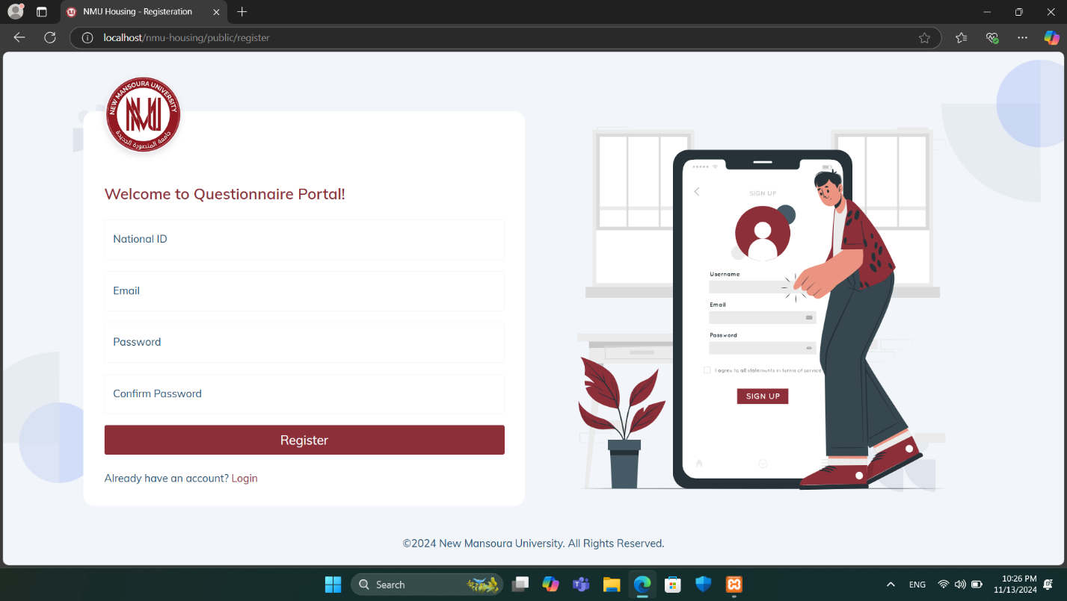

The **Registration Page** is the entry point for new users to sign up for access to the **NMU Questionnaire Portal**. This page requires users to fill in the following fields:

* **National ID:** A unique identifier required for user verification.
* **Email:** The user's email address, which will be used for communication and login purposes.
* **Password:** A secure password created by the user.
* **Confirm Password:** Ensures accuracy by requiring users to re-enter their password.

After filling out these fields, users can click the **Register button to complete the sign-up process**.

A link below the registration form allows users who already have an account to quickly switch to the Login page. The welcoming design and clear instructions make the sign-up process simple and user-friendly, encouraging ease of access to the questionnaire system.

## Login Page

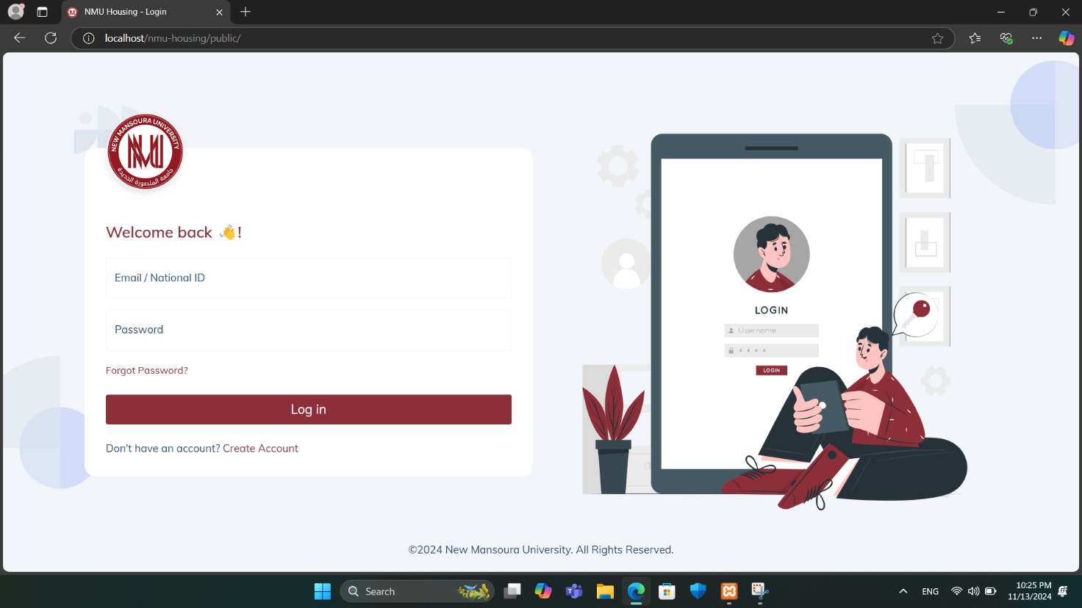

The **Login Page** contains the following:

1. **Logo and Welcome Message**:
   * The New Mansoura University logo is prominently displayed to reinforce brand identity.
   * A welcoming message ("Welcome back!") creates a friendly atmosphere for returning users.
2. **Login Fields**:
   * **Email / National ID**: Field to enter either an email address or a National ID, catering to diverse login preferences.
   * **Password**: Field for users to enter their password securely.
3. **Additional Options**:
   * **Forgot Password?**: A link for users to recover their password if forgotten, improving user experience.
   * **Don’t have an account? Create Account**: A prompt for new users to register for an account if they don't already have one.
4. **Login Button**:
   * A large, clearly visible **Log in** button to submit login credentials and access the system.

## Reset Password Page

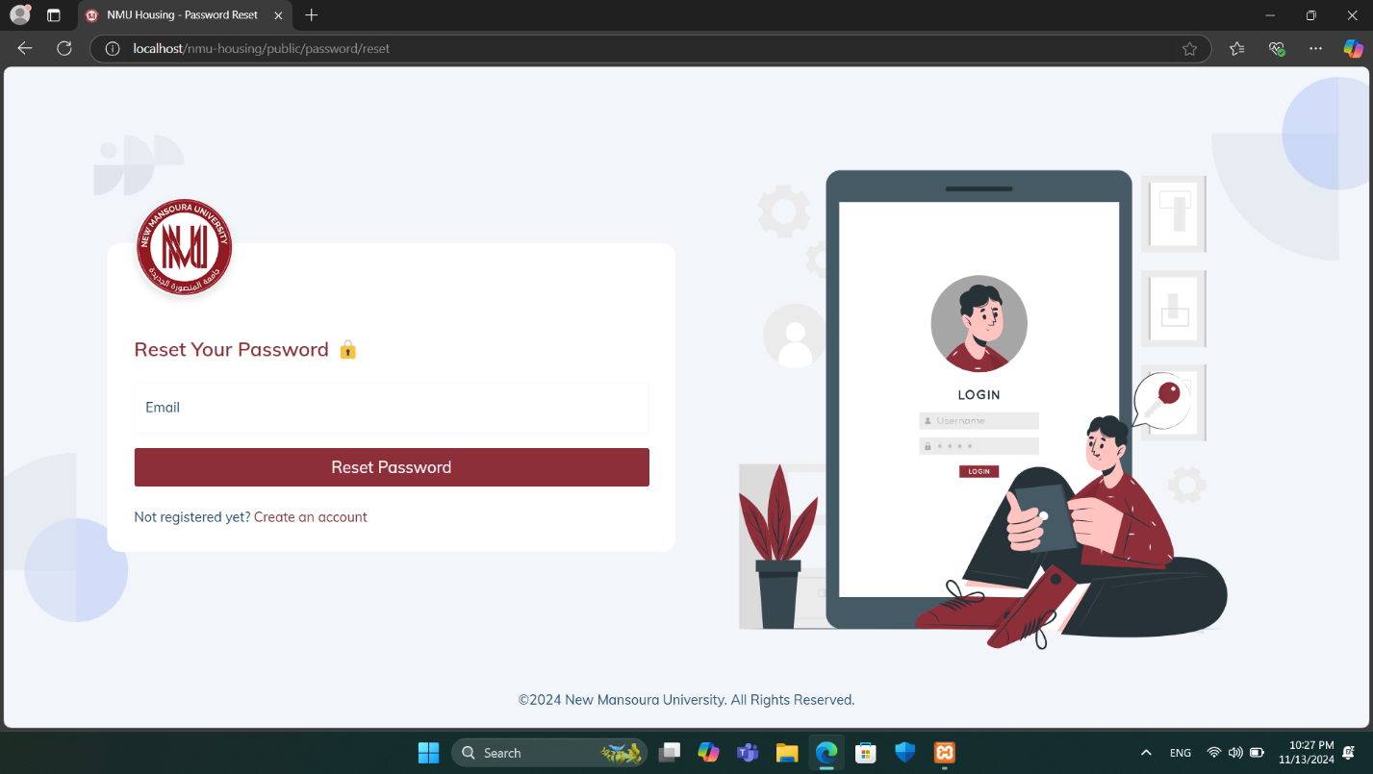

The **Reset Password page** allows users to recover access to their account by requesting a password reset.

* **Email Field:** Users enter the email associated with their account.
* **Reset Password Button:** Initiates the password reset process. Upon clicking, the system verifies the email and, if valid, sends reset instructions to the user’s email.
* **Account Creation Link:** A link for users who are not yet registered, providing a direct path to create an account.

This page ensures a straightforward process for account recovery.

## Dashboard Page

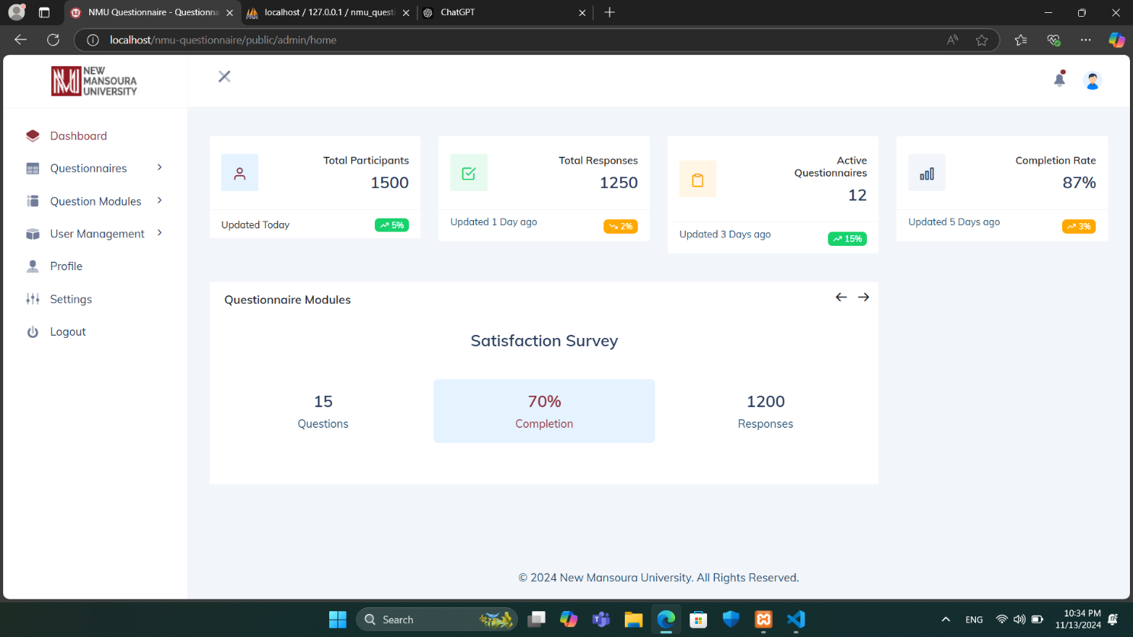

The **Dashboard page** provides an overview of key metrics and statistics related to questionnaires within the system. It includes the following sections:

* **Statistics Summary:** Displays key metrics, including:
* **Total Participants:** Shows the total number of users who participated in questionnaires, with the last update time and recent change percentage.
* **Total Responses:** Indicates the number of questionnaire responses, along with an update timestamp and recent change percentage.
* **Active Questionnaires:** Lists the number of currently active questionnaires, along with recent activity indicators.
* **Completion Rate:** Provides the overall completion rate of questionnaires, showing the percentage and last update details.
* **Questionnaire Modules:** Displays active modules containing preset questions, such as the "Satisfaction Survey." For each module, the system shows the current completion percentage, the number of responses, and the total number of questions. Arrows allow navigation through different modules if multiple sets of preset questions are available.

The left sidebar provides navigation options for accessing other sections, including Questionnaires, Question Modules, User Management, Profile, Settings, and Logout.

## Profile Page

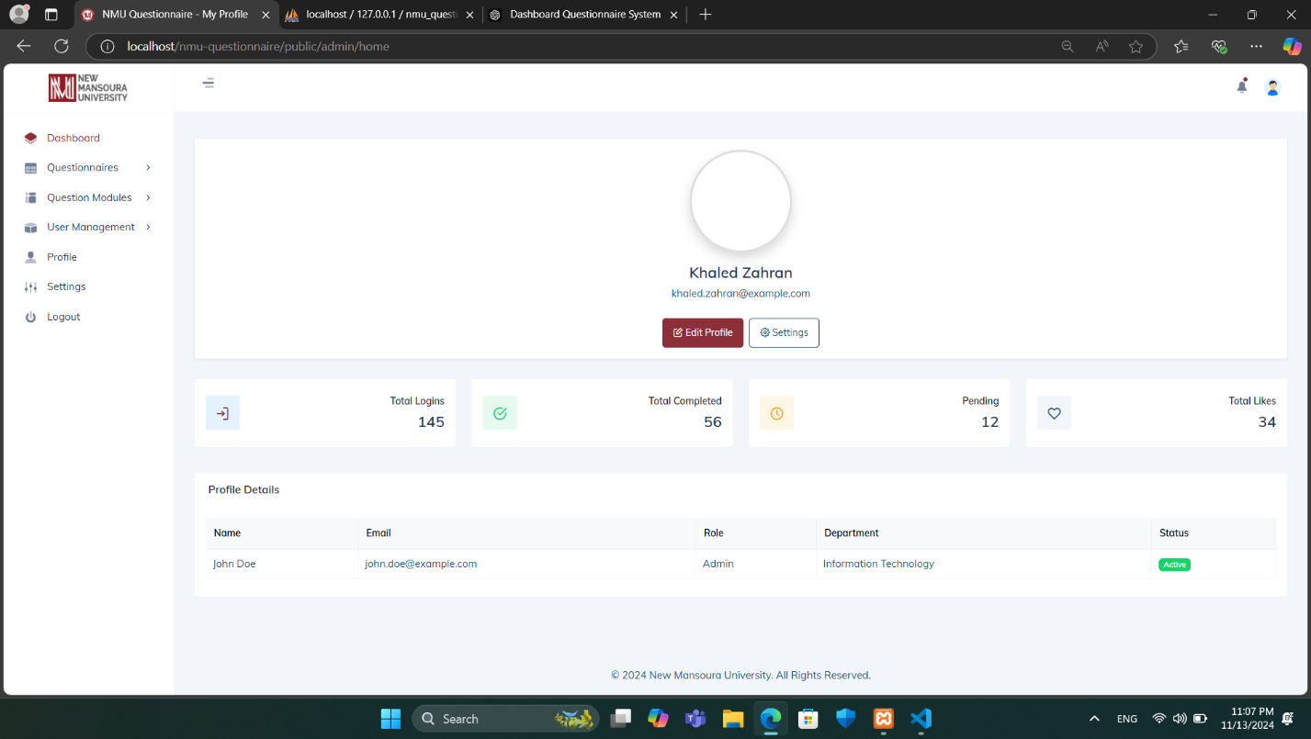

The **Profile page** provides users with an overview of their account details and activity. At the top, the user’s name and email are displayed, accompanied by options to Edit Profile and access Settings for customization. Below this section, a summary of key metrics is shown, including:

* **Total Logins:** Displays the number of times the user has logged into the system.
* **Total Completed:** Indicates the number of questionnaires or activities completed by the user.
* **Pending:** Shows the count of pending tasks or questionnaires assigned to the user.
* **Total Likes:** Reflects the total likes or approvals received, potentially from other users or administrators.

In the **Profile Details section**, information such as the user’s name, email, role (e.g., Admin), department (e.g., Information Technology), and account status (e.g., Active) is displayed. This provides a quick reference to the user’s role and departmental association within the system.

This page allows users to monitor their engagement within the system and keep track of their profile information and activity status.

## Create Questionnaire page

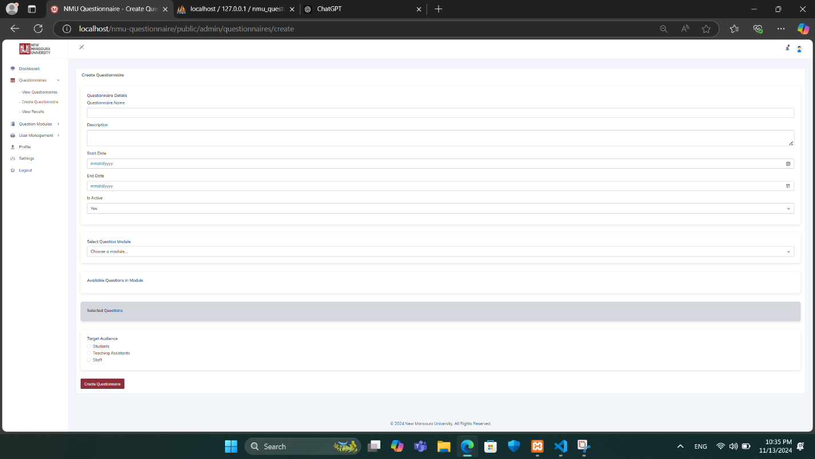

The **Create Questionnaire page** contains the following:

1. **Questionnaire Details**:
   * **Questionnaire Name**: Field for entering the name of the questionnaire.
   * **Description**: Field to provide a brief description or purpose of the questionnaire.
   * **Start Date & End Date**: Date pickers to set the active period for the questionnaire, specifying when it will be available to respondents.
   * **Is Active**: Option to toggle the active status of the questionnaire.
2. **Select Question Module**:
   * **Choose a Module**: Dropdown menu to select a preset question module created earlier. This enables the reuse of standardized question sets across multiple questionnaires.
   * **Available Questions in Module**: Displays the questions within the selected module for review.
3. **Selected Questions**:
   * Displays a list of questions selected from the module or added manually.
4. **Target Audience**:
   * Options to select the intended audience for the questionnaire, such as **Students**, **Teaching Assistants**, or **Staff**.
5. **Controls**:
   * **Create Questionnaire**: Button to save and deploy the questionnaire with the selected modules and settings.

This page enables administrators to customize questionnaires based on specific objectives, target audiences, and timelines, making it easier to manage diverse survey requirements.

## View Questionnaires Page

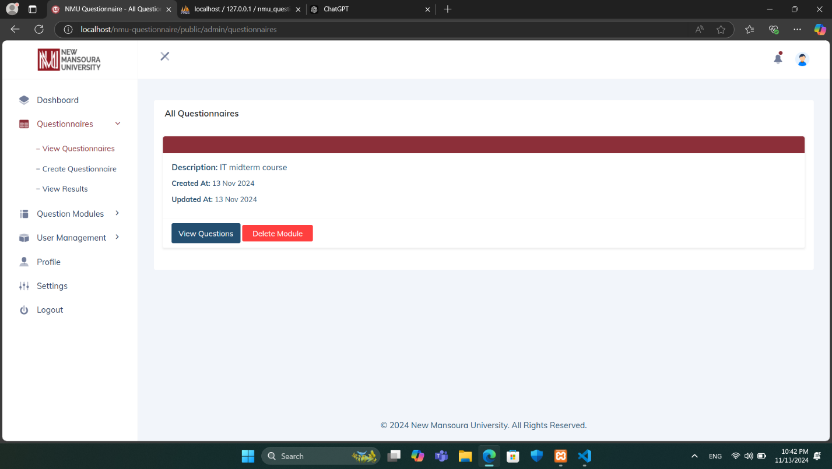

The **View Questionnaires page** provides a comprehensive list of questionnaires available within the system. Each questionnaire entry displays key information, including a brief Description (e.g., "IT midterm course") and the dates when it was Created and Updated.

For each questionnaire, users have two primary actions available:

* **View Questions:** Opens the questionnaire for a detailed view of all questions included within this specific module.
* **Delete Module:** Permanently removes the questionnaire from the system.

The left sidebar offers quick navigation to other areas of the application, including Questionnaires (for viewing, creating, and analyzing results), Question Modules, User Management, Profile, Settings, and the option to Logout.

This page is particularly useful for administrators and educators to manage and track questionnaires efficiently, ensuring that they can access, update, or delete questionnaires as needed.

## Create Questionnaire Modules Page

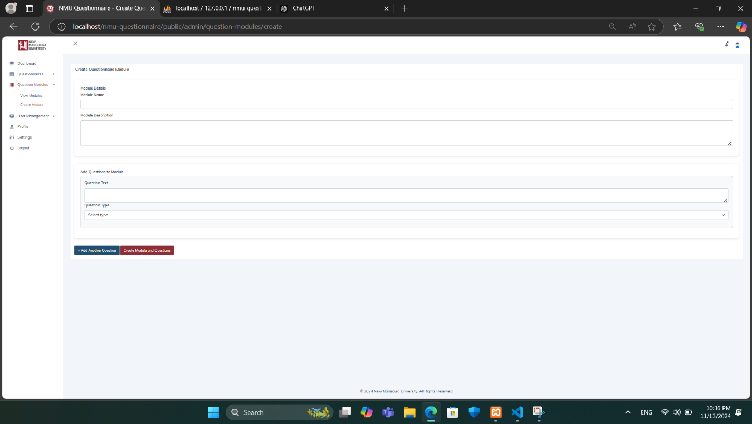

The **Create Questionnaire Modules** **page** contains the following **Module Details**:

* **Module Name:** Field for naming the module to describe its purpose (e.g., "Course Feedback").
* **Module Description:** Field to provide additional context about the module.
* **Add Questions to Module:** Button to add questions to the module.
* **Question Text:** Field to enter the text of each question to be included in the module.
* **Question Type:** Dropdown menu to select the type of question (e.g., multiple-choice, short answer, rating scale).
* **Create Module and Questions:** Button to save the module and its questions, making it available for use in questionnaires.

This page is designed to streamline the creation of standardized question sets, facilitating easier and more consistent questionnaire building.

## View Questionnaire Modules Page

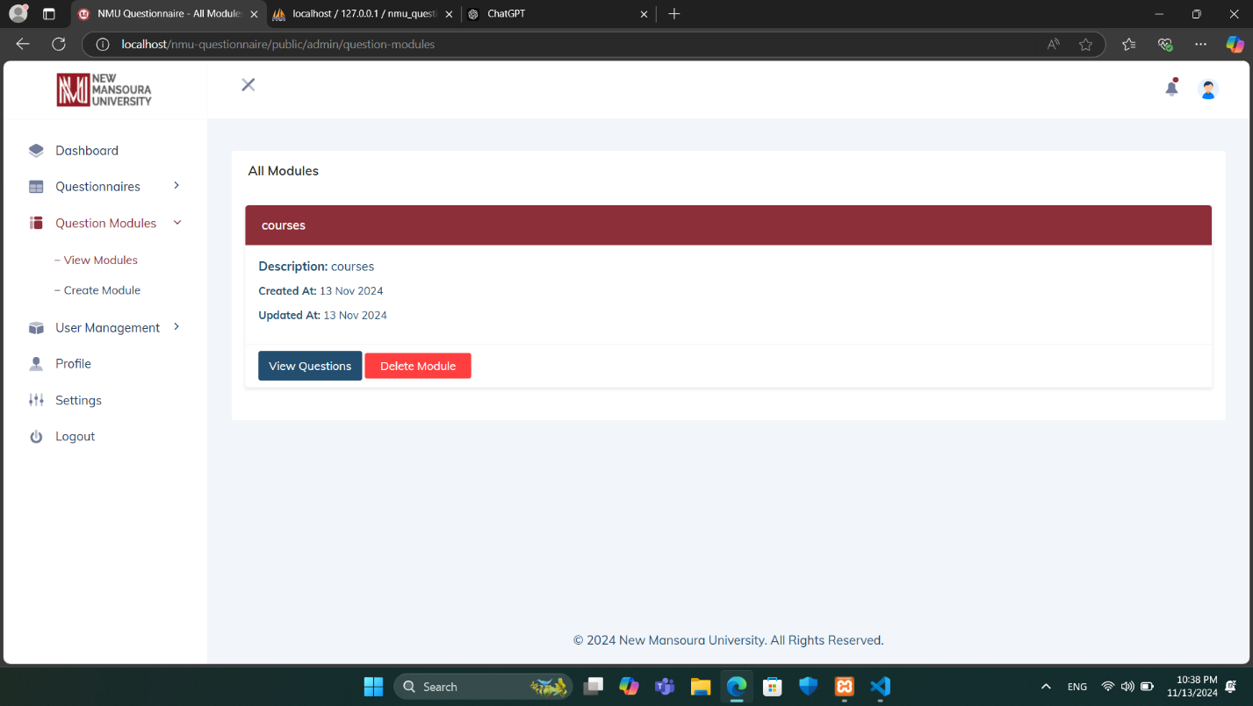

The **View Questionnaire Modules** page within the **Question Modules** section provides administrators with an organized view of available questionnaire modules in the system.

In the main panel, each module is displayed with the following details:

* **Title**: The name of the module, shown prominently in a red header for clear identification.
* **Description**: A brief description summarizing the purpose of the module.
* **Created At**: The date when the module was created.
* **Updated At**: The date of the last update to the module.

For each module, administrators have two main options:

* **View Questions**: This button allows the administrator to view all questions associated with the selected module.
* **Delete Module**: This button enables the administrator to remove the module from the system.

This page serves as a centralized interface for administrators to manage questionnaire modules, ensuring streamlined access to module details and maintenance options.

## Questionnaire View and Response Page

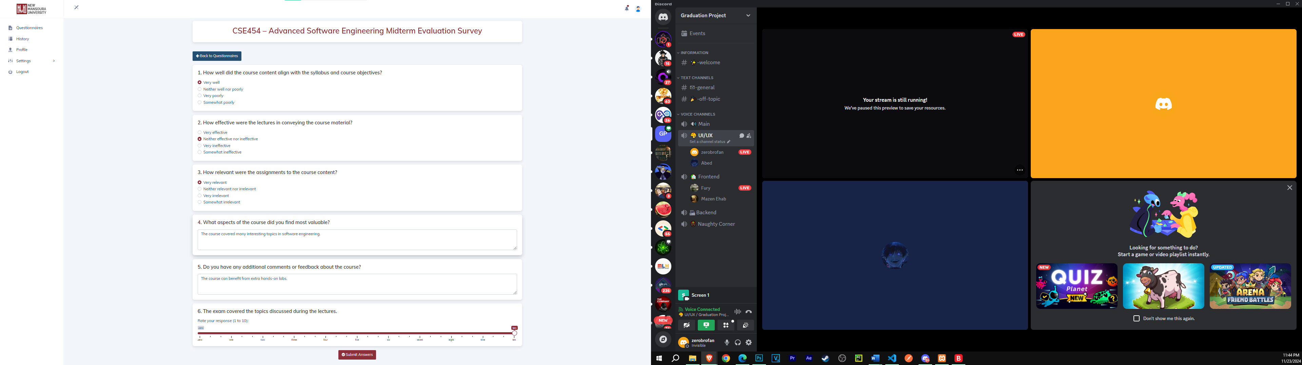

The **Questionnaire View and Response Page** allows users to participate in and respond to a survey that has been created. The layout of the page is structured for ease of use and clarity:

1. **Header Section**:
   * The title of the questionnaire is prominently displayed, including the course name and survey type (e.g., "CSE454 – Advanced Software Engineering Midterm Evaluation Survey").
   * A navigation button ("Back to Questionnaires") is available for returning to the main questionnaire list.
2. **Questionnaire Content**:
   * The survey consists of multiple questions, presented in a clean, card-like format.
   * Questions include various formats, such as:
     + **Multiple-choice**: Options are displayed with radio buttons for selecting a single response.
     + **Text fields**: Open-ended questions allow users to provide feedback or comments.
     + **Slider scales**: Users can rate their responses on a numeric scale (e.g., 0–10) with a draggable slider for precise input.
3. **Interaction**:
   * Each question is spaced adequately to ensure readability and smooth navigation.
   * Input fields and selection options are intuitive and responsive.
4. **Submission Options**:
   * At the bottom of the questionnaire, users are provided with two buttons:
     + **Submit Answers**: Finalizes the responses and submits them.
     + **Save Draft**: Allows users to save their progress and return later to complete the questionnaire.

This page is designed to provide a seamless experience for users to interact with and complete surveys efficiently, supporting both structured and open-ended feedback collection.

## User Management – View Users page

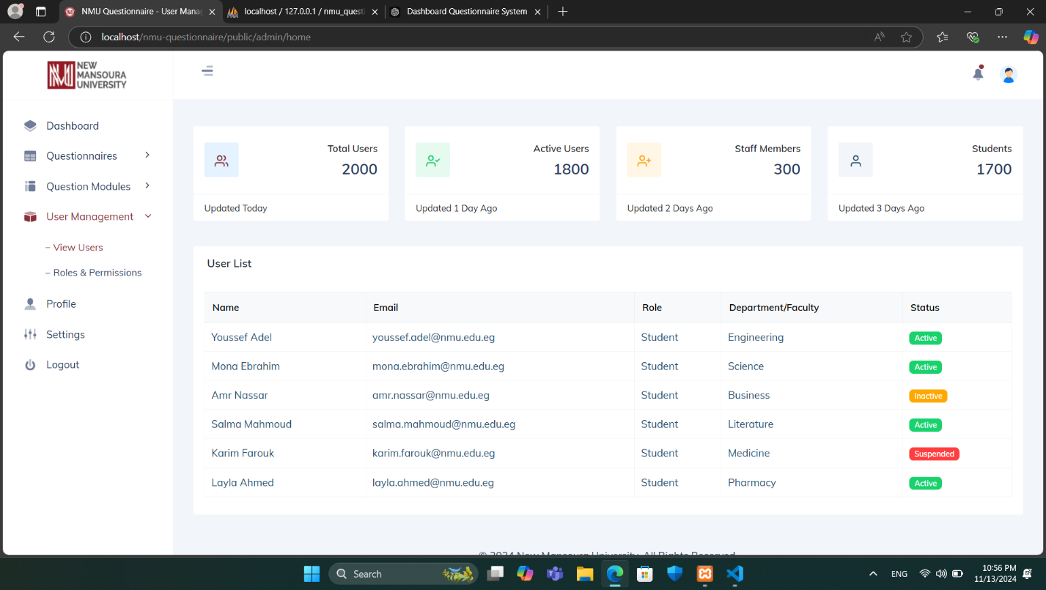

The **View Users page** within **User Management** provides administrators with an overview of system users and key statistics. **At the top of the page, a series of summary cards display:**

* **Total Users:** The total number of users registered in the system.
* **Active Users:** The count of users who are currently active.
* **Staff Members:** The number of users who are staff members.
* **Students:** The count of users identified as students.

**Each card includes the date of the last update for reference.**

Below the summary, the **User List table** provides a detailed view of individual users. The table displays information such as:

* **Name:** The user’s name.
* **Email:** The user’s email address.
* **Role:** The role assigned to the user, such as “Student” or “Staff.”
* **Department/Faculty:** The department or faculty associated with the user.
* **Status:** The current status of the user, displayed as color-coded labels for easy identification, including “Active” (green), “Inactive” (yellow), and “Suspended” (red).

This page allows administrators to monitor and manage user information at a glance, helping maintain an organized and secure system.

## User Management – Roles & Permissions Page

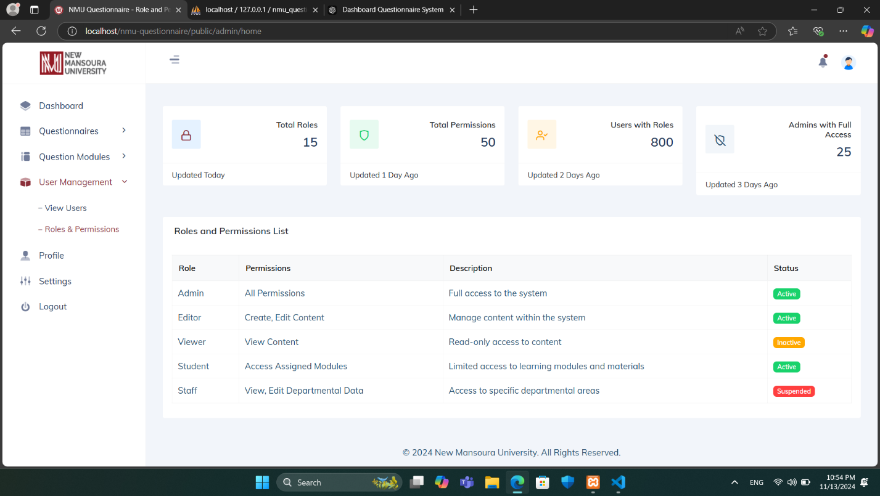

The **Roles and Permissions page** within **User Management** provides an overview of user roles within the system, along with their associated permissions and statuses. Key components of this page include:

* **Total Roles:** Displays the total number of unique roles in the system.
* **Total Permissions:** Shows the total number of distinct permissions assigned across roles.
* **Users with Roles:** Indicates the total number of users with assigned roles.
* **Admins with Full Access:** Shows the number of administrators who have full system access.
* **Role:** Lists different roles, such as Admin, Editor, Viewer, Student, and Staff.
* **Permissions:** Describes the permissions associated with each role, such as full access, content editing, view-only access, or access to specific modules.
* **Status:** Indicates the current status of each role (e.g., Active, Inactive, Suspended).

This page helps administrators manage and maintain system security by defining role-based permissions.

# Technologies Used

The **NMU Questionnaire Management System** leverages the following technologies:



* **PHP:** Backend scripting language used for server-side logic and functionality.
* **Laravel:** PHP framework for building a scalable and maintainable backend with MVC architecture.
* **Bootstrap:** Frontend framework for responsive and mobile-first web design.
* **HTML:** Markup language for structuring the system's web pages.
* **CSS:** Styling language for designing the visual appearance of the user interface.
* **JavaScript:** Programming language for client-side interactivity and dynamic functionality.

# Required Data

To run the **NMU Questionnaire System** effectively, specific data about users must be collected. This data is categorized into two main groups: **Students and Staff**, with their respective attributes as follows:

| **User Type** | **Required Data** |
| --- | --- |
| **Student** | - Name (First Name, Last Name) |
|  | - National ID (Unique Identifier) |
|  | - University ID (Academic Identifier) |
|  | - Faculty (e.g., Computer Science & Engineering) |
|  | - Department (e.g., Computer Science, Artificial Intelligence) |
|  | - Program (e.g., Software Engineering, Cybersecurity) |
|  | - Level (e.g., First Year, Second Year) |
|  | - Academic Email (e.g., student@nmu.edu.eg) |
| **Staff** | - Name (First Name, Last Name) |
|  | - National ID (Unique Identifier) |
|  | - Department (e.g., IT, Student Affairs) |
|  | - Academic Email (e.g., example@nmu.edu.eg) |
| **Teaching** | - Name (First Name, Last Name) |
|  | - National ID (Unique Identifier) |
|  | - Faculty (e.g., Faculty of Engineering, Faculty of Science) |
|  | - Academic Email (e.g., prof@nmu.edu.eg) |

## ****Data Usage****

The information mentioned in the previous table is essential for:

* **User registration and authentication.**
* **Generating customized questionnaires tailored to the user type.**
* **Analyzing responses based on faculty, department, or role demographics.**

# **Future Work**

Although significant progress has been made, additional work is required to fully complete the **NMU Questionnaire System**. The following are the planned next steps:

## ****Backend and Infrastructure Enhancements****

* **Backup Mechanism**: Implement automated data backups ensure reliability and recovery.
* **Production Environment**: Deploy the system in a scalable and secure production environment.
* **Performance Optimization**: Optimize database queries and API responses for better scalability.

## ****Advanced Features****

* **Analytics Dashboard**: Enhance the dashboard to include advanced analytics and reporting for administrators.
* **Multi-language Support**: Add support for additional languages to improve accessibility for a broader audience.

## ****Security and Access Control****

* **Role-Based Permissions**: Finalize and test granular permissions for various user roles.
* **Data Encryption**: Ensure all sensitive data is encrypted at rest and during transmission.

## ****Testing and Quality Assurance****

* Conduct rigorous integration and end-to-end testing to ensure a seamless user experience.
* Address any issues discovered during testing and perform user acceptance testing (UAT).

## ****Documentation and Deployment****

* Complete technical and user documentation for maintenance and onboarding.
* Provide training sessions for system administrators and users before the full-scale launch.